

Внеклассное мероприятие

"Autumn Adventures in English"
For 7-9 grades
Тема: Осенние традиции в англоязычных странах (США, Великобритания, Канада)
Цели:
Стимулировать интерес к изучению английского языка;
Развить навыки говорения, аудирования, чтения и командной работы;
Познакомить обучающихся с осенними традициями англоязычных стран;
Развить творческие способности через интерактивные задания.
_____________________________________________________________________________

Event Plan
I. Introduction (5 minutes)
Teacher: Good afternoon, everyone! Welcome to our "Autumn Adventures in English" event! Today, we’ll dive into the colorful season of autumn, explore how it’s celebrated in English-speaking countries. Are you ready? Let’s split into three teams and choose a fun autumn-themed name for your team, like "Falling Leaves," "Pumpkin Power," or "Harvest Moon.".
Tasks:
- Divide students into three teams
- Each team picks a name and creates a quick team chant in English (e.g. “Falling Leaves” – “We believe, English fun we will achieve!”)
- Briefly introduce the event structure: a mix of quizzes, discussions and creative tasks about autumn

II. Warming-Up: Autumn Vocabulary Challenge (10 minutes)
Teacher: Let’s start with some autumn vibes! Look at these pictures and match the words to what you see. Then, show off your creativity by making sentences. The team with the most points and the best sentences wins this round!
Tasks:
- Display a slideshow with images of autumn scenes (falling leaves, pumpkins, Thanksgiving tables, etc.)
- Hand out a worksheet with 10 autumn-related words (e.g. harvest, scarecrow, bonfire, foliage, cider, crisp, cozy, orchard, sweater, equinox).
- Match words to the images or definitions. Each correct answer earns 1 point for the team.
Bonus Round: Teams create 2-3 sentences using the words (e.g. “The crisp air made the orchard visit cozy). The most creative sentence earns an extra point.

III. Cultural Quiz: Autumn in English-speaking countries (10 minutes)

Teacher: Fall is celebrated differently around the world. Let’s test your knowledge about how English-speaking countries enjoy this season. Work as a team, discuss, and write your answers. Ready? Let’s go!

Quiz:
Present a quiz with 8 multiple-choice or true/false questions about autumn traditions.
Sample questions
  - In the USA, Thanksgiving is celebrated in which month?
a) September b) October c) November (Answer: c)
  - True or False: In Canada, people carve pumpkins into jack-o'- lanterns for Halloween. (Answer: True)
  - What fruit is commonly used in American pies during autumn?
a) Mango b) Apple c) Pineapple (Answer: b)
  - What is the name of the UK holiday celebrated on November 5 with bonfires and fireworks?
a) Halloween b) Guy Fawkes Night c) Harvest Festival (Answer: b)
  - In the UK, what is another name for autumn?
a) Fall b) Spring c) Harvest (Ответ: a)
  - What is a popular autumn drink in the USA?
  - a) Iced tea b) Pumpkin spice latte c) Hot chocolate (Ответ: b)
  - In Canada, what animal is often associated with autumn migrations?
a) Geese b) Bears c) Deer (Ответ: a)
Teams discuss answers together and write them on a whiteboard. Each correct answer earns 1 point.

IV. Autumn Storyboard (10 minutes)
Teacher: Now it’s time to get creative! Use these props and your imagination to create an autumn story set in the USA, UK, or Canada. Include our vocabulary words and cultural traditions. You have 10 minutes to write and then present your story to everyone!

Tasks:
- Each team receives a set of autumn-themed props (e.g. fake leaves, a mini pumpkin, a scarf)
- Create a short storyboard (3-4 scenes) for an autumn-themed story set in an English-speaking country. The story must include at least 5 vocabulary words from the warm-up and one cultural element (e.g. Thanksgiving, Halloween or Guy Fawkes Night)
- Students write a brief description of each scene in English (2-3 sentences per scene)
- One student from each team presents the storyboard to the class.
- Scoring: 1 point for each vocabulary word used correctly, 1 point for including a cultural elements and up to3 points for creativity (judged by the teacher or students’ vote)
Sample Storyboard:
- Scene 1: On a crisp autumn day, Sarah visits an orchard in Canada to pick apples for Thanksgiving.
- Scene 2: She sees colorful foliage and a pumpkin, feeling cozy in his sweater.
- Scene 3: At home, Sarah enjoys cider by a bonfire with friends, celebrating the harvest.

V. Interactive Game: Autumn Charades (8 minutes)
Teacher: Let’s have some fun with charades! One person from your team will act out an autumn action or object, and you guess in English. Be quick and loud—let’s see which team guesses the most!
Tasks:
- Prepare cards with autumn-related actions or objects (e.g. raking leaves, carving a pumpkin, drinking hot cider, jumping in a leaf pile)
- One student from each team acts out a card without speaking while their team guesses in English within 30 seconds
- Each correct guess earns 1 point. Rotate players so everyone gets a chance.
- Optional: Play a short autumn-themed song (e.g. “Sweet September” by Acoustic Alchemy in the background to set the mood)

VI. Conclusion and Feedback (5 minutes)
Teacher: What a fantastic adventure! Let’s give a big round of applause to all our teams! Which team has the most points? [Announce winner.] Now, tell me one thing you learned today or a new word you’ll use this autumn. Thank you for joining, and let’s keep exploring English together!
Tasks:
- Announce the winning team based on total points and distribute small prizes (e.g. stickers or bookmarks)
- Ask students to share one new thing they learnt about fall or English-speaking cultures (e.g. “I learned that Guy Fawkers Night is a big even in the UK”)
- Encourage students to use one new vocabulary word in a sentence about their own autumn experiences.

Extra Notes
- Preparation:
√ Create a slideshow with autumn images and quiz questions.
√ Print worksheets and charades cards in advance
√ Decorate the classroom with autumn props (leaves, pumpkins) for atmosphere.
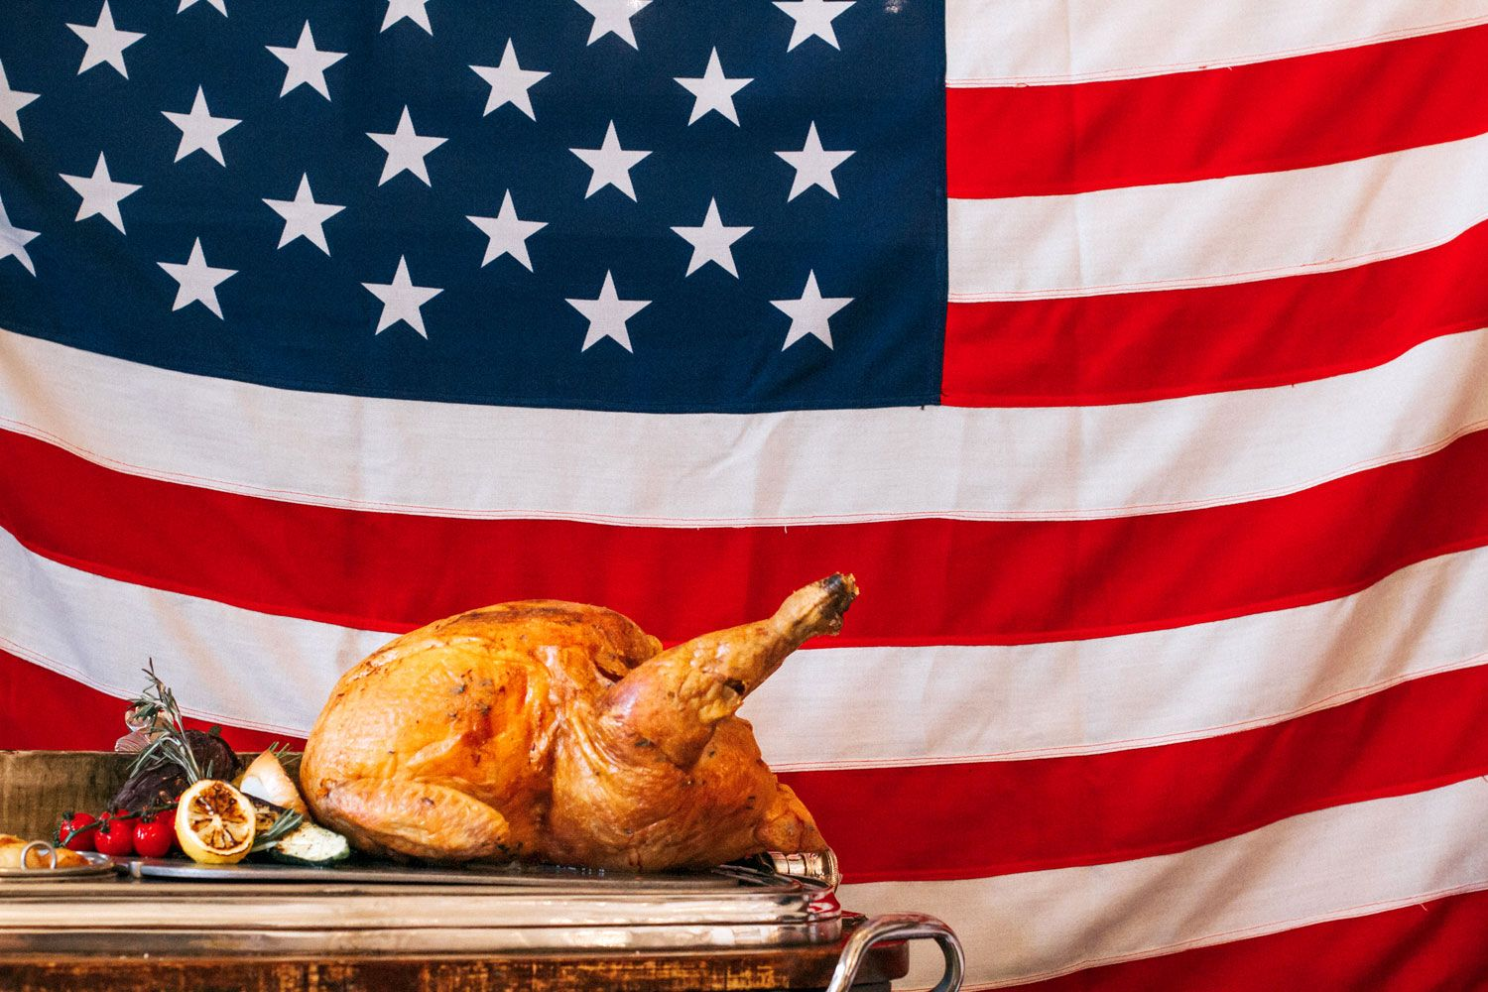
- Cultural Relevance: The event ties to September/October 2025 by focusing on a autumn, aligning with holidays like Halloween (October 31) and Thanksgiving Day (late November in the US, October in Canada)

